|  |
| --- |
| Functional Design |
| The Client: Going Green |

**Revision History**

|  |  |  |  |
| --- | --- | --- | --- |
| **Date** | **Revision** | **Description** | **Author** |
|  | 1.0 | Initial Draft | Team |
|  |  |  |  |
|  |  |  |  |

Table of contents

1 Introduction 1

1.1 Overview 1

1.2 Terminology 1

1.3 General Assumptions 2

2 GUI Design 2

3 Functionality 8

3.1 <Detailed Functional Description> 9

3.2 <Detailed Functional Description> 9

3.3 <Detailed Functional Description> 9

3.4 <Detailed Functional Description> 9

3.5 <Detailed Functional Description> 9

4 Special Character/ Unicode Considerations 10

5 Reference Data / New Security Nodes 11

6 Language Considerations 11

7 Billing Considerations 11

8 Performance / SLAs Considerations 12

9 Database Size Implications / Message Volumes 12

10 Data Center Implications 12

10.1 Data Center Security 12

10.2 Software 12

10.3 Hardware 12

11 Future Considerations 12

12 Issues 13

# Introduction

## Overview

Carpooling for the Green Initiative must do the following:

* Allow users to set up, edit and delete their profiles.
* Allow users to find/create a carpool.

Carpooling for the Green Initiative should do the following:

* Provide an easy-to-use interface for the users.
* Provide 100% up-time.
* Be consistently designed throughout all screens.

Carpooling for the Green Initiative could do the following:

* Include a cost calculator for determining the cost for those in the carpool.
* Include duplicate functionality for re-creating the same group.
* Include a messaging system for the driver and commuters to communicate.
* Include a map to plot the locations of those in the carpool and to also plot a route for the driver.

Carpooling for the Green Initiative won’t do the following:

* Crash when used improperly.

## Terminology

| **Term** | **Definition** |
| --- | --- |
| Group | The individuals, including the driver, that commute together as designated by the system. |
| Meeting Place | Pre-determined meeting places for commuter groups. |
| To Work Group | The Carpool group that will take the users to work |
| To Home Group | The Carpool group that will take the users home |
| Fee Calculator | A feature that determines the cost each passenger will have to pay to cover gas cost. |
| Members | Users who have been accepted into a group |
| Driving Schedule | A list that tracks when a driver is designated to drive throughout the week |
| Leader | The Member that has Administrator privileges within a group |

## General Assumptions

The following assumptions apply:

1. Application is installed on an Android device.
2. The user has currently active cell phone service.
3. The user is able to send text messages via SMS/MMS.
4. The user has Google Maps installed on their device.

# GUI Design

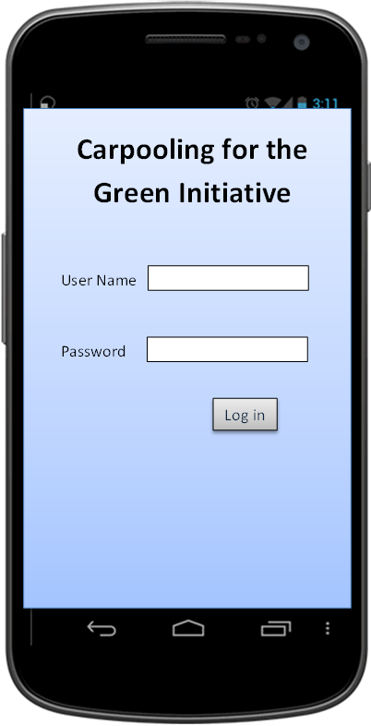

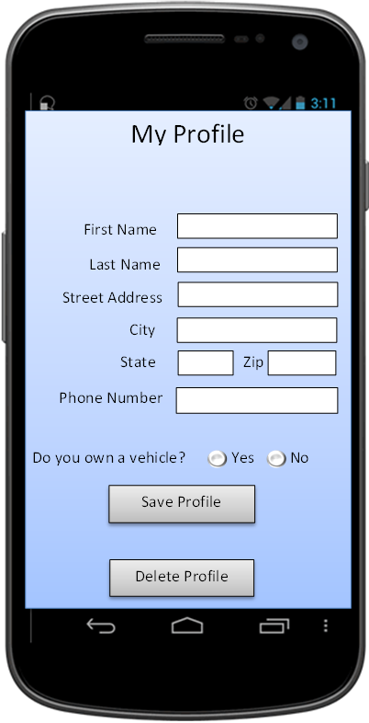

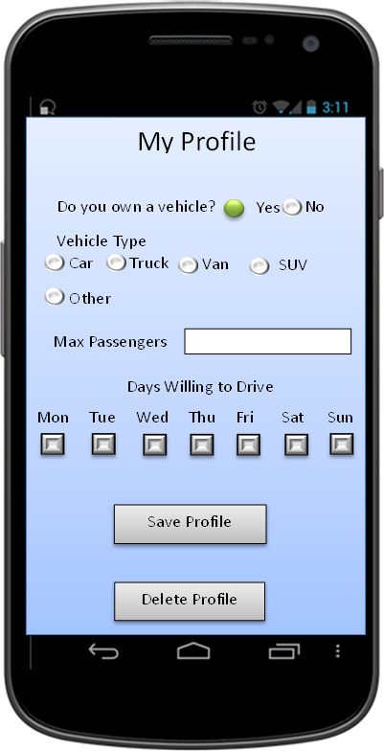

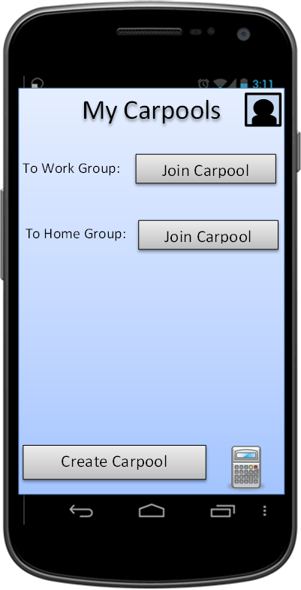

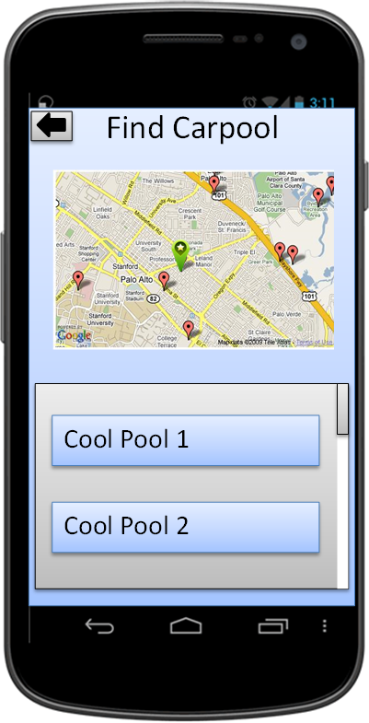

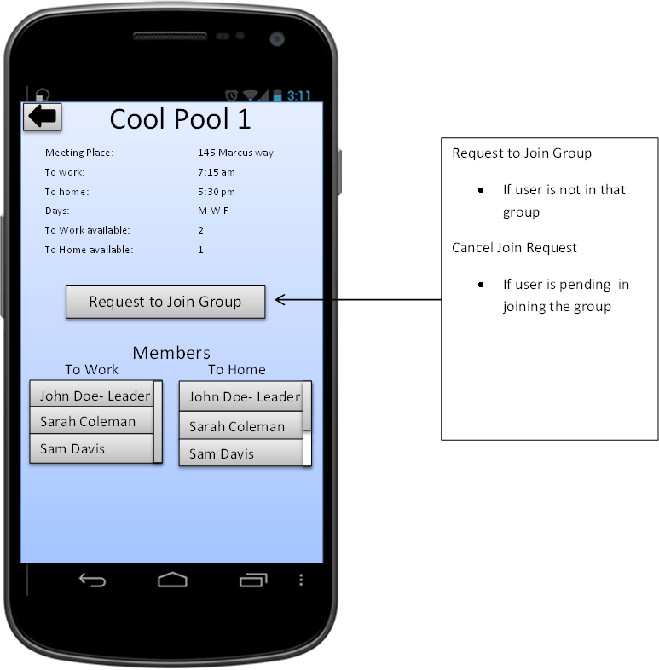

# Functionality

The following modifications/new development will be made in order to accommodate the functionality:

1. <Name of process, brief description of process, etc.>
2. <Name of process, brief description of process, etc.>
3. <Name of process, brief description of process, etc.>
4. <Name of process, brief description of process, etc.>
5. <Name of process, brief description of process, etc.>
6. <Name of process, brief description of process, etc.>

## <Detailed Functional Description>

<Detailed description of item above.>

## <Detailed Functional Description>

<Detailed description of item above.>

## <Detailed Functional Description>

<Detailed description of item above.>

## <Detailed Functional Description>

<Detailed description of item above.>

## <Detailed Functional Description>

<Detailed description of item above.>

# Special Character/ Unicode Considerations

|  |  |  |  |  |
| --- | --- | --- | --- | --- |
| **Field Name** | **Required (Y/N)** | **Length** | **Character Type** | **Unicode/Special Character Accepted (Y/N)** |
| Person.UserID | Y | 255 | Text | Y |
| Person.UserPass | Y | N/A | Memo/Long Text | Y |
| Person.FirstName | Y | 25 | Text | Y |
| Person.LastName | Y | 25 | Text | Y |
| Person.AddressStreet | Y | 255 | Text | Y |
| Person.AddressCity | Y | 255 | Text | Y |
| Person.AddressState | Y | 255 | Text | Y |
| Person.AddressZip | Y | 10 | Text | Y |
| Person.PhoneNum | Y | 14 | Text | Y |
| Person.PendingArrival | N/A | N/A | Yes/No | N/A |
| Person.PendingDeparture | N/A | N/A | Yes/No | N/A |
| Person.ArrivalGroup | N/A | N/A | Number | N/A |
| Person.DepartureGroup | N/A | N/A | Number | N/A |
| Person.LeaderOfGroups | N/A | N/A | Number | N/A |
| Person.DriveSun | N/A | N/A | Yes/No | N/A |
| Person.DriveMon | N/A | N/A | Yes/No | N/A |
| Person.DriveTue | N/A | N/A | Yes/No | N/A |
| Person.DriveWed | N/A | N/A | Yes/No | N/A |
| Person.DriveThu | N/A | N/A | Yes/No | N/A |
| Person.DriveFri | N/A | N/A | Yes/No | N/A |
| Person.DriveSat | N/A | N/A | Yes/No | N/A |
| Person.WillDrive | N/A | N/A | Yes/No | N/A |
| Person.VehicleType | N | 15 | Text | Y |
| Person.MaxPassengers | N | N/A | Number | N/A |
|  |  |  |  |  |
| Group.GroupName | N | 50 | Text | Y |
| Group.AddressStreet | Y | 255 | Text | Y |
| Group.AddressCity | Y | 255 | Text | Y |
| Group.AddressState | Y | 255 | Text | Y |
| Group.AddressZip | Y | 10 | Text | Y |
| Group.MeetTime | Y | N/A | Date/Time | N/A |
| Group.DepartTime | Y | N/A | Date/Time | N/A |
| Group.Driver | Y | N/A | Number | N/A |
| Group.Leader | Y | N/A | Number | N/A |
| Group.Members | N | N/A | Number | N/A |
| Group.DriverSunday | Y | N/A | Number | N/A |
| Group.DriverMonday | Y | N/A | Number | N/A |
| Group.DriverTuesday | Y | N/A | Number | N/A |
| Group.DriverWednesday | Y | N/A | Number | N/A |
| Group.DriverThursday | Y | N/A | Number | N/A |
| Group.DriverFriday | Y | N/A | Number | N/A |
| Group.DriverSaturday | Y | N/A | Number | N/A |

Special characters include but are not limited to.

[`~@#$%^\&*(){}[]|":;'?><.,_+=-/]

# Reference Data / New Security Nodes

Carpooling for the Green Initiative will use the following Reference Data to validate user credentials. The data will be copied to CGI servers as updates are made to the client system.

* UserID-for the User Name.
* UserPass-for the Password.

# Language Considerations

**Portal**

The Client Portal supports multiple languages for online pages.

Languages supported:

* All languages currently supported will be translated.

# Billing Considerations

The client has provided a $25,000 budget for this service. With this budget, a team of four consultants will implement the following plan to ensure that the most effective use of the money provided is executed.

Labor Cost:

* 3 weeks – Development
* 3 weeks – Testing
* 6 weeks – Total Project Time

Service Cost

* Data Storage
* Security cost

# Performance / SLAs Considerations

Carpooling for the Green Initiative should provide 100% uptime while a data connection is available to the user. Downtime maximum should be no longer than a period of 24 hours.

# Database Size Implications / Message Volumes

* Carpooling for the Green Initiative will add 1 row per user of the company to the Person table.
  + The impact is expected to be minimal as the growth will only be on initialization of the data.
* Carpooling for the Green Initiative will add 1 row per new group creation by the users to the Group table.
  + The impact is expected to be somewhat severe since new groups will likely be created frequently. This will only increase as the user base for the application increases in size.
* Carpooling for the Green Initiative will remove 1 row for each group deletion by the users from the Group table.
* Carpooling for the Green Initiative will not add or remove any columns from the database.

# Data Center Implications

## Data Center Security

* There is no additional third party server or application required for the data center security.
* No additional ports or firewalls need to be opened up with exception to the standard ones.

## Software

* No new software will be required.
* No updates to existing software will be required.

## Hardware

* Minimum additional hardware will be required.

# Future Considerations

Future works:

* Leader can remove members from the group which they are the leader of.
* Leader can reply to invite request via the use of SMS/MMS.
* App will be available cross platform. Notably on iOS.

# Issues

<List issue that may affect the project>

1. <Issue 1, details, etc.>
2. <Possible resolutions or feedback from others.>
3. <Possible resolutions or feedback from others.>